**HCI Proposal:**

**Swampy Frog Games**



**Made By:**

Christian Antonio Yotanka Tampubolon - 2702389442

1. **BASE DESCRIPTION**

The project that I decided to make is an e-commerce website called “Atlantic Skull Apps”. Atlantic Skull Apps is an online video game supermarket that allows you to download and buy indie video games and some corporate games that aren’t too well known. This website is inspired by a few apps and websites that I myself used to get video games, such as; Apple’s App Store, Valve’s Steam, and the Epic Games App.

The difference between the aforementioned apps and the site that I myself am building is that this site exclusively sells, allows you to download and markets nothing other than indie games, especially the ones that need massive recognition.

1. **PROBLEM ANALYSIS**

I observed that a lot of indie game developers would give up on their dreams of creating their dream games due to the lack of popularity of their games, even though when I played their games, their games tend to be very fun and playing through them became memorable experiences for me. It saddens me to see that some people don’t get to have the same experience due to the lack of knowledge that said game’s exist. A lot of people often play games that are trending, so these video games tend to be buried under rubble. What motivated me to make this website is so that these people would have the opportunity to let they’re games be seen in broad daylight and increase the popularity of such games

I understood why these games lack the attention that I think they need. This comes from many factors such as:

* Massive games and their corporations tend to overshadow these indie corporations and games
* Since the specialty of video game developers isn’t marketing, there isn’t any way that we can ensure that they can market their games properly
* Not only that, people who develop video games tend to promote them in various places such as Instagram, facebook, etc which isn’t a place people go to find video games
* Promotion also requires money, and an indie game developer isn’t guaranteed to make enough money to pay for such ads

**Objective(s):**

* To let lesser known indie games be known and let indie game developers keep doing what they love
* To get video game companies to scout for great game developers and programmers to recruit them or buy their games
* To let gamers worldwide to know that there are good indie games out there
* To make sure that other indie developers find out about other developers to allow collaboration between indie developers happen more

1. **PERSONA: WILL SHLATNER**



William Jacob Shlatner is an 18-year old college freshman who works as a barista at a cafe near his apartment complex part-time. Due to this, he always seems to have a busy schedule and he usually comes home late. William is an aspiring game developer, currently studying in the University of Ontario. He’s currently developing a video game with his friends Jamie and Stewart with their own funding.

Hobbies: Hanging out with friends, Gaming, Streaming, Listening to Music

Likes: Rock Music, Video Games, Cold Brew Coffee, Mythology, Sci-Fi

Dislikes: Pop Music, Frat Parties, Large Crowds

1. **PROTOTYPE DESIGN:**

Before coming up with the name Swampy frog games, the initial name of the website was   
“Atlantic Skull Apps”. This was changed because a pirate themed website would give off the wrong idea and make people assume that the website’s purpose was for piracy. “Swampy Frog Games” was chosen because frogs are considered to be animals found in camping grounds, thus making sure that the website has a comforting appearance, similar to the comforting essence of a campfire during summer camp.

Atlantic Skull Apps, now known as Swampy Frog Games is designed to be user friendly. It initially was designed to have a search bar and category selector which allows the user to find specific games they’re looking for based on their preferred genre. When a game is selected, the user is able to read the description of said selected games, view snapshots and download the game presented on the website. There will be a plethora of games to choose from.

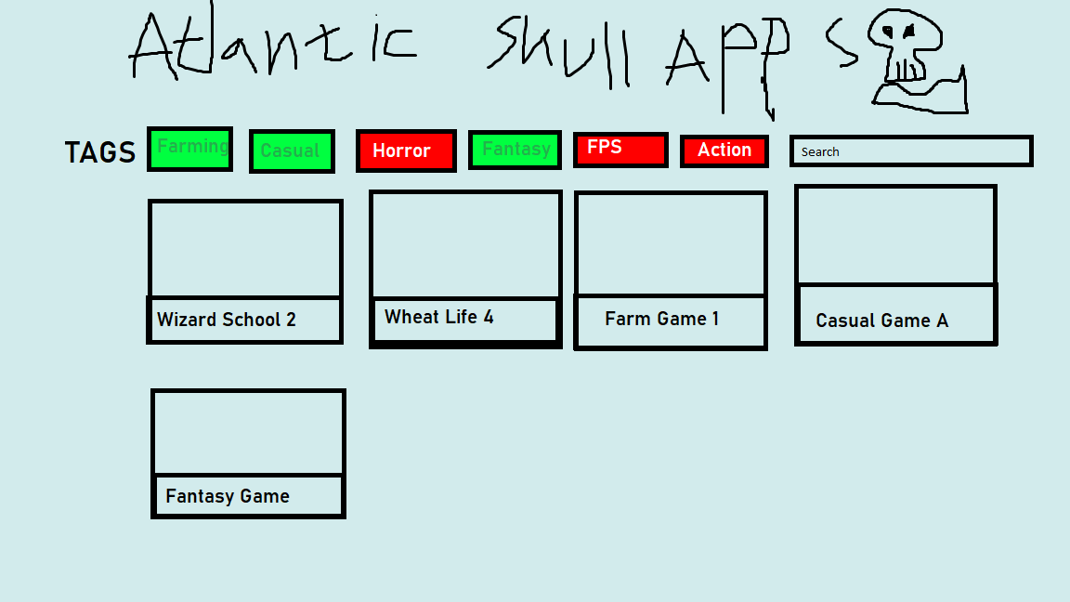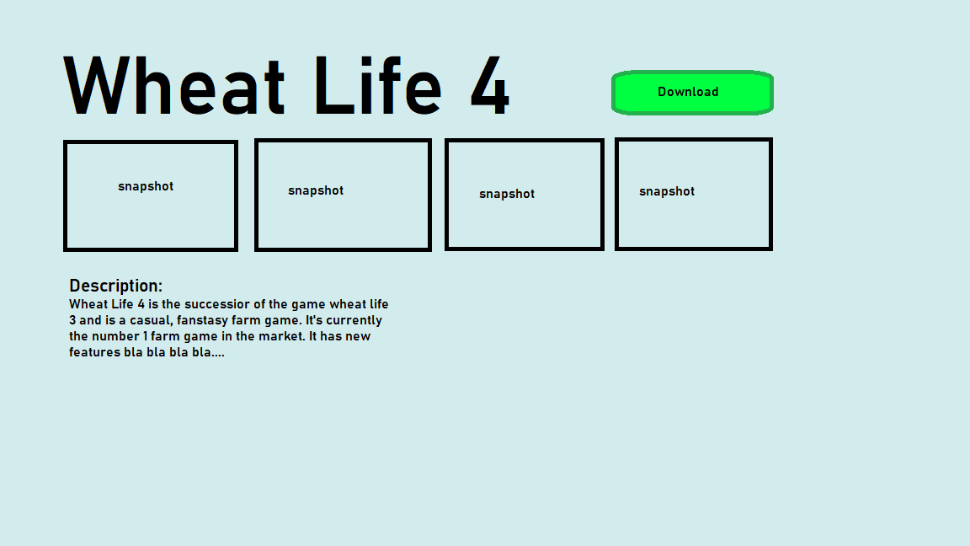

1. **WIREFRAME**

Not long after the prototype was created and a few test websites were created, a wireframe was created and held on designs of six different pages. These pages include the home page, the about page, the developers page, the genre page, the purchase page and the download page.

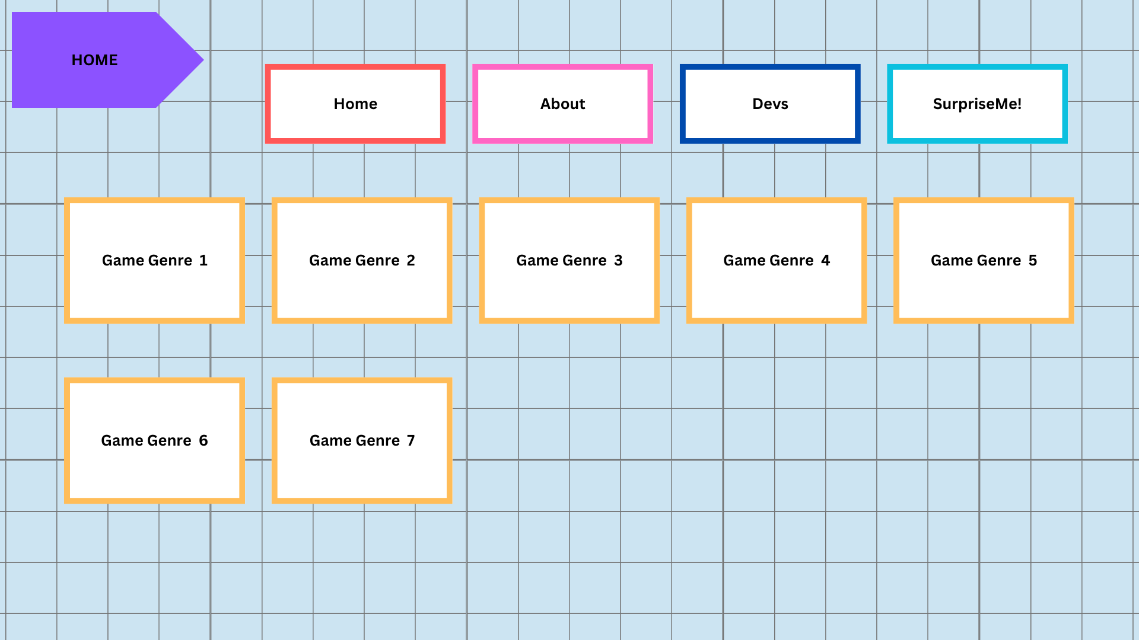

**(img 5.1: the homepage)**

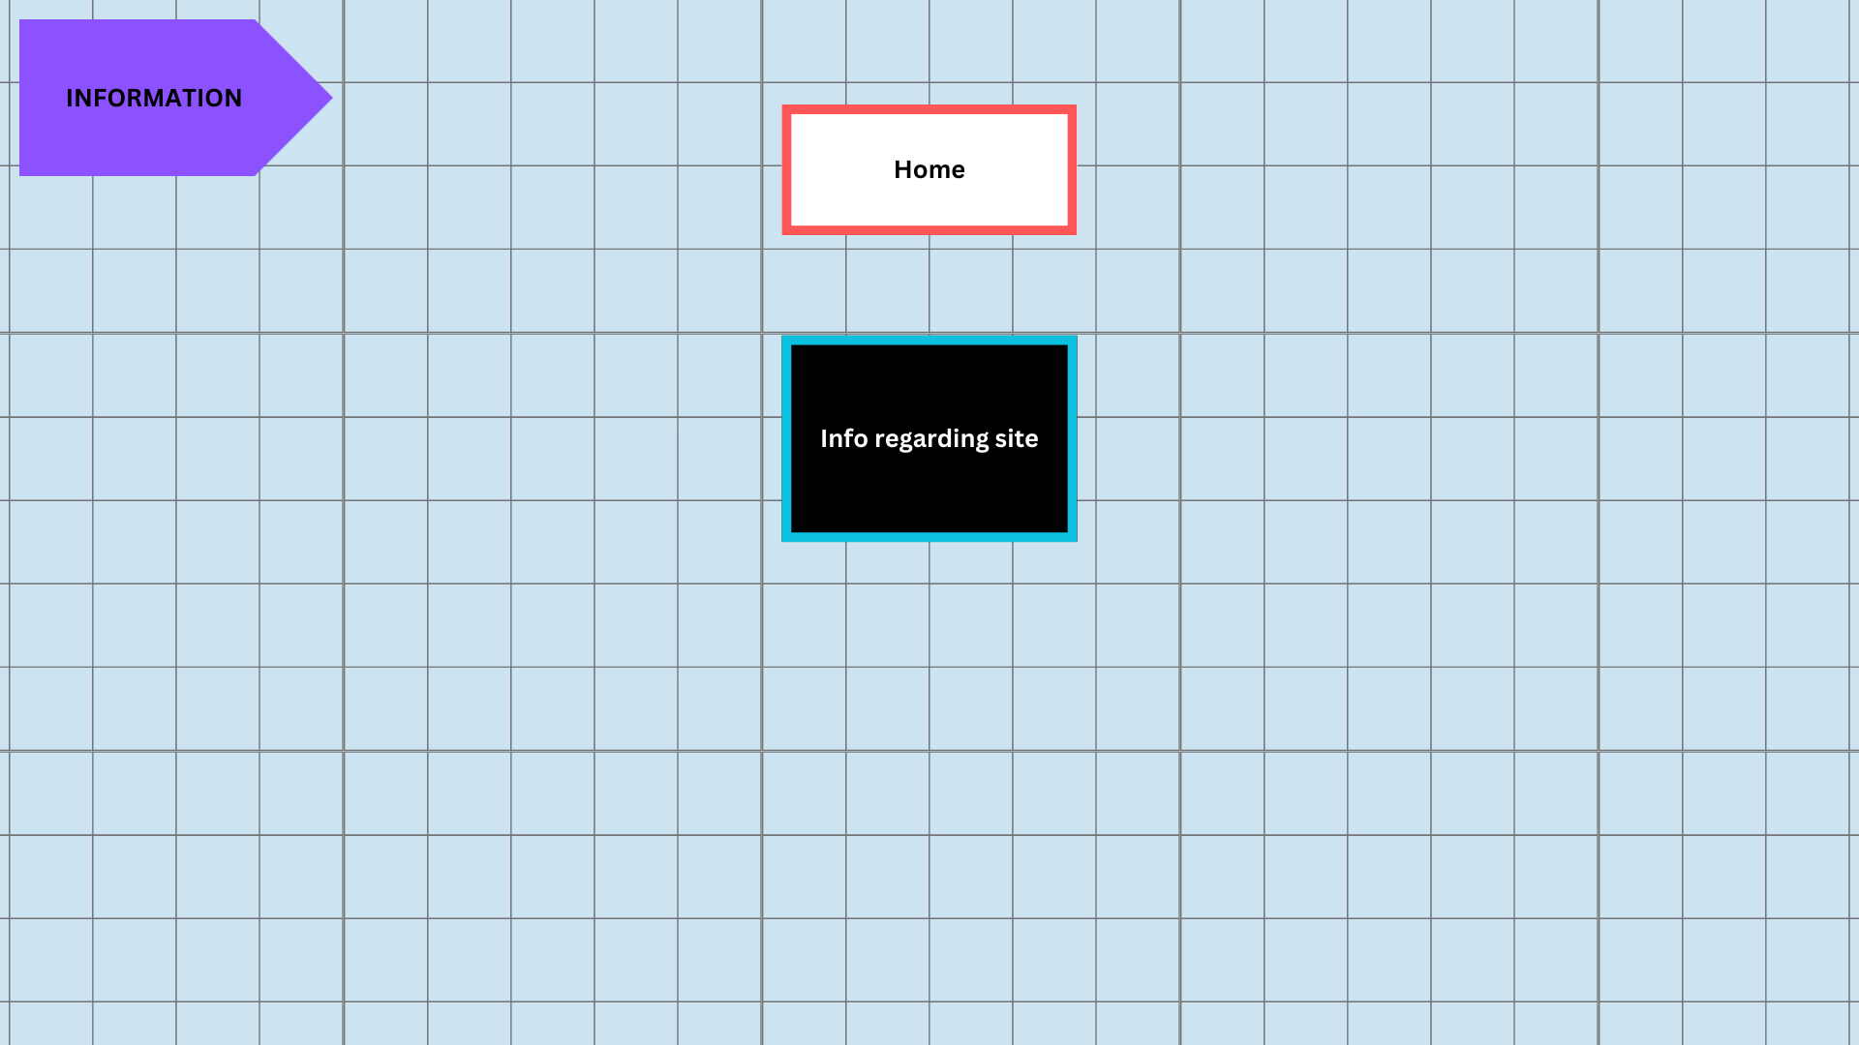

**(img 5.2: the info page)**

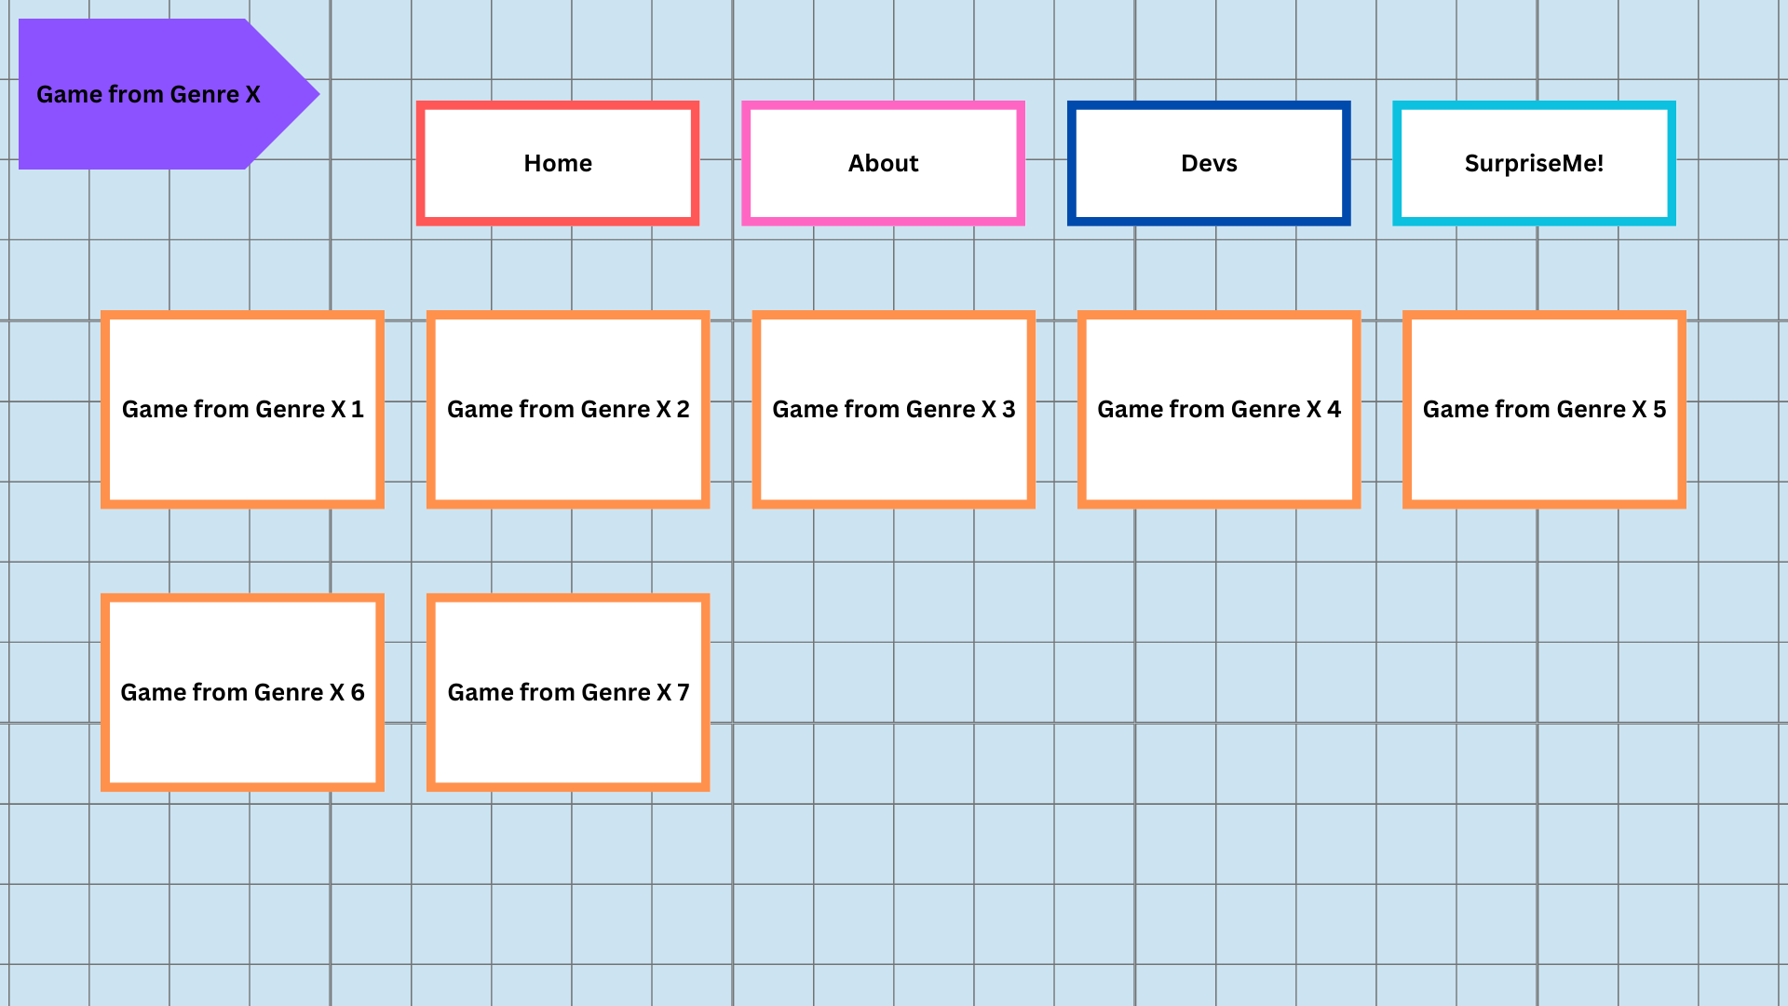

**(img 5.3: the developers page)**

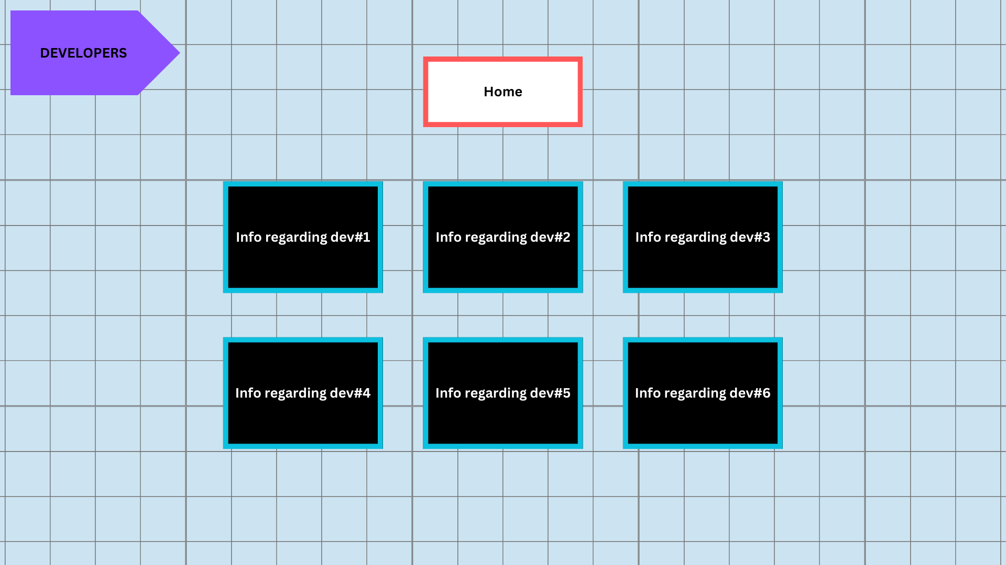

**(img 5.4: the genre page)**

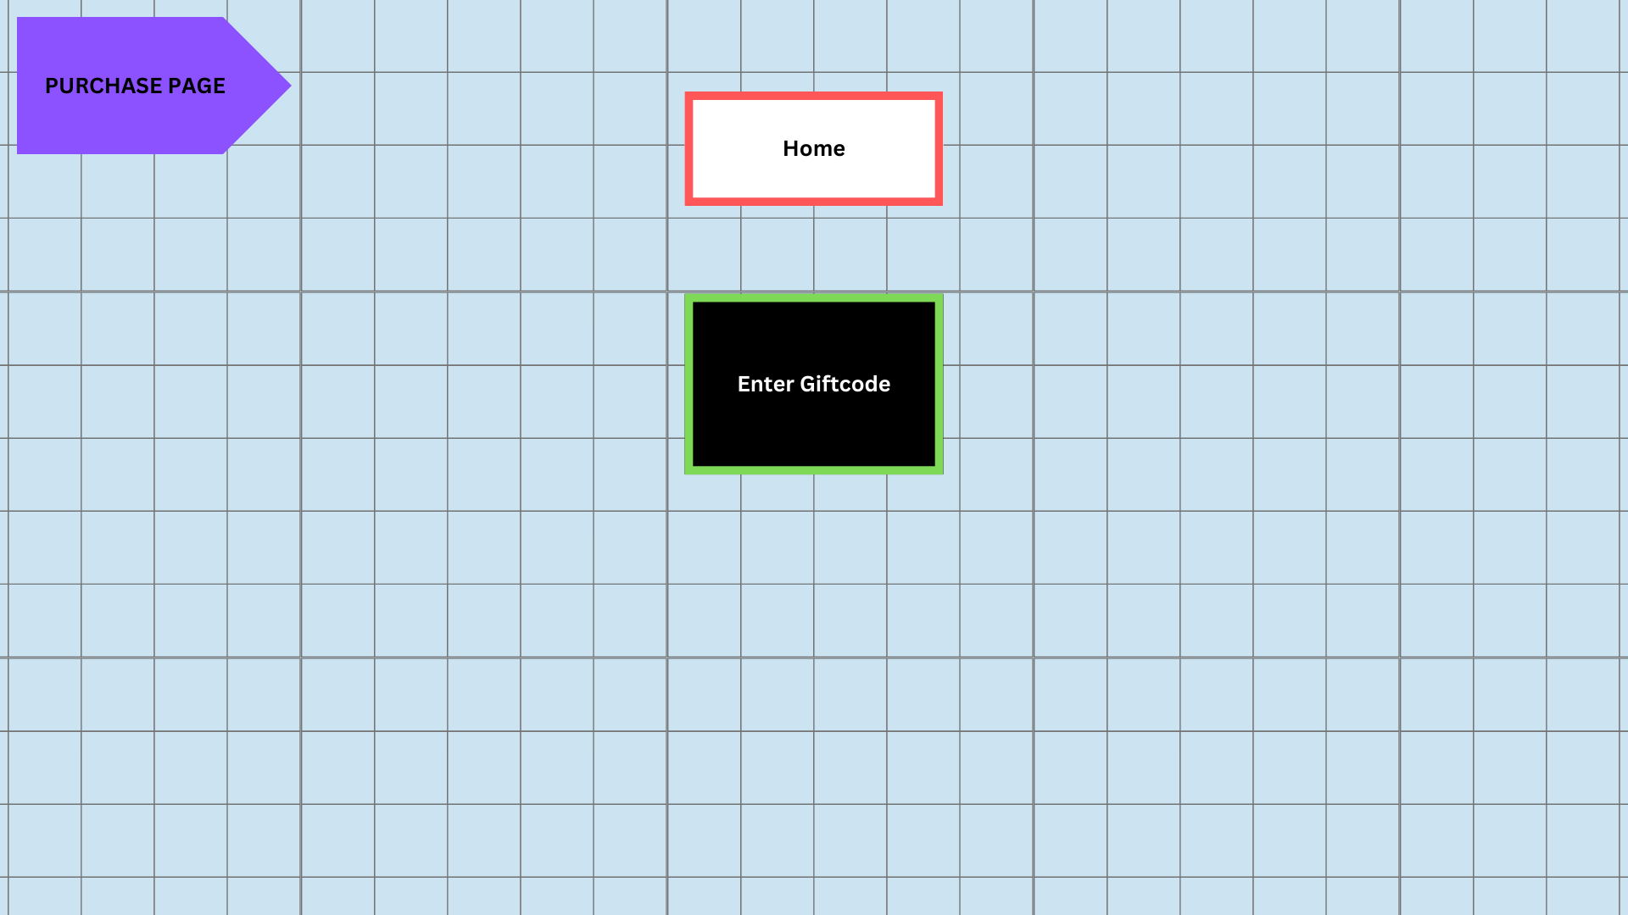

**(img 5.5: the purchase page)**

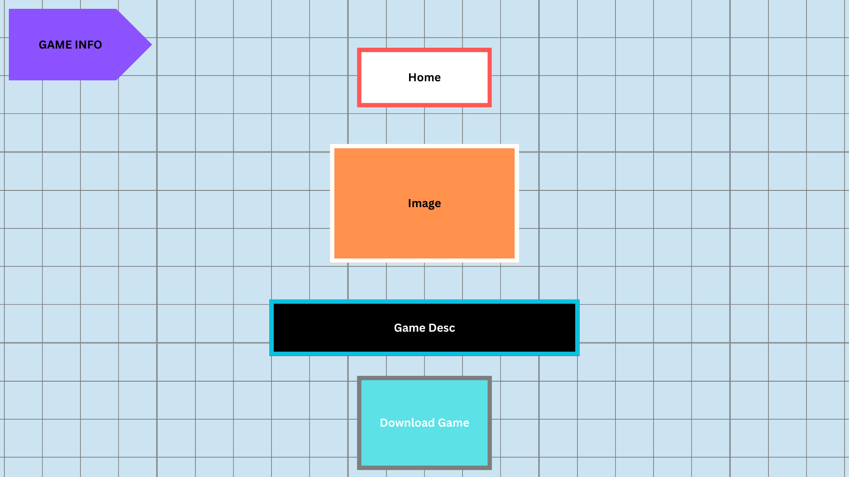

**(img 5.6: the download page)**

1. **STORYBOARD**
2. **INFORMATION ARCHITECTURE**
3. **Flowchart**

This flowchart consists of the information architecture regarding the website “Swampy Frog Games”

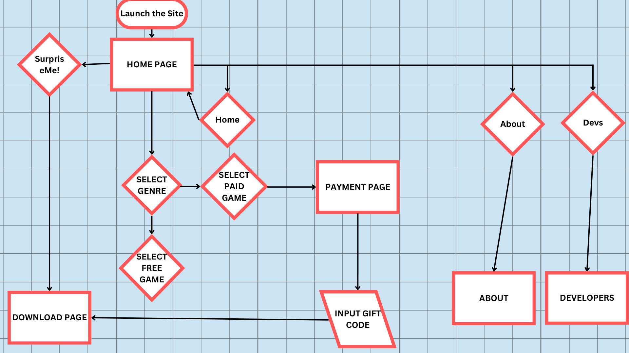

1. **SCREENSHOTS**

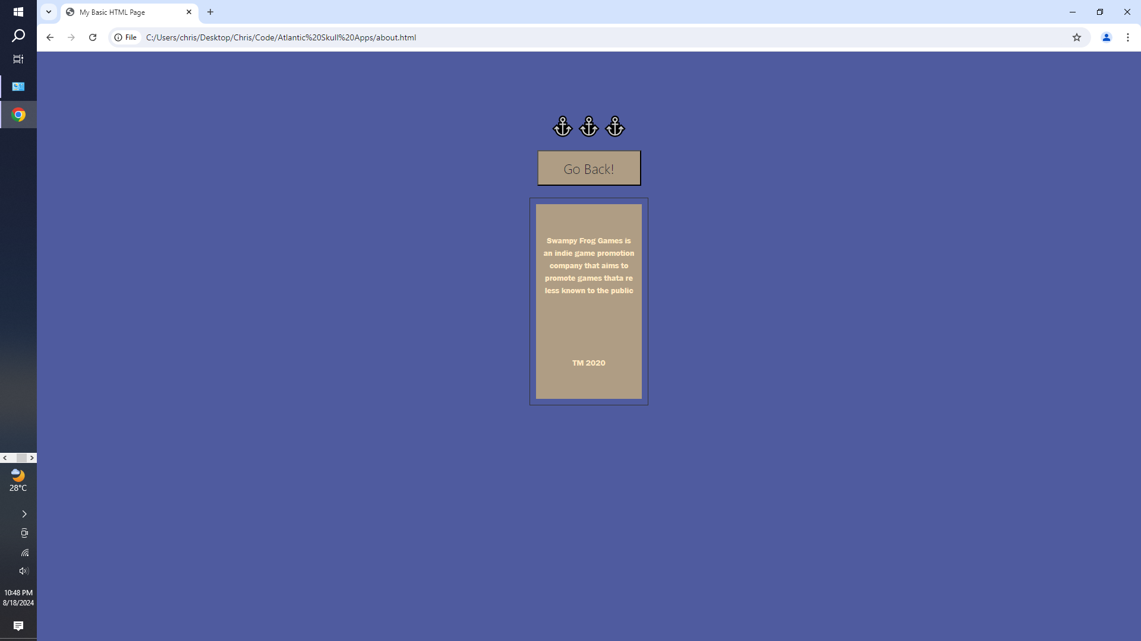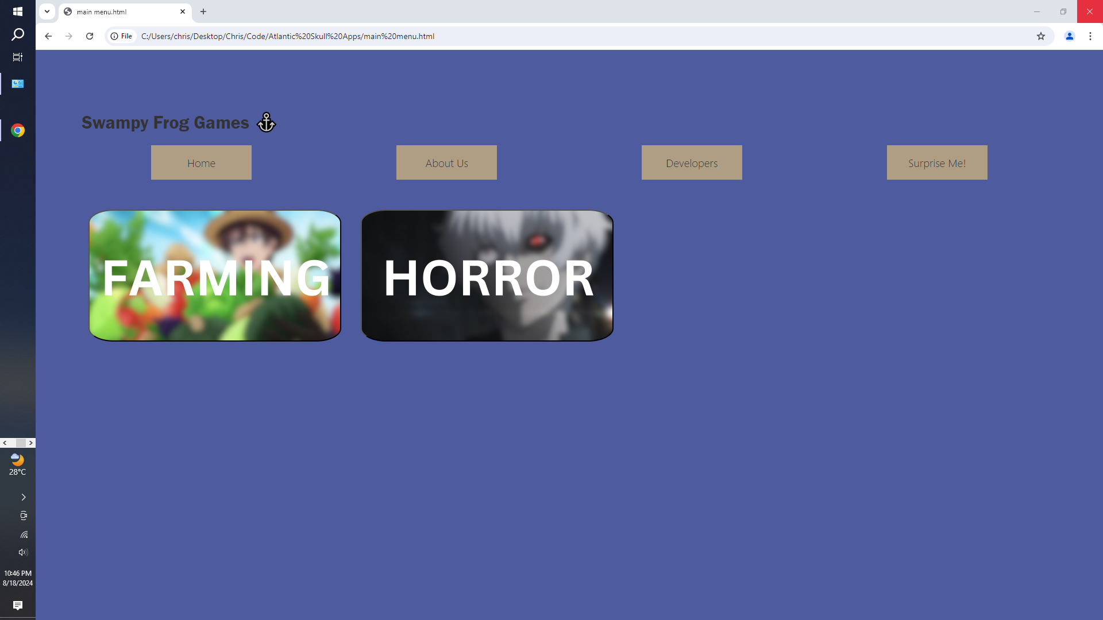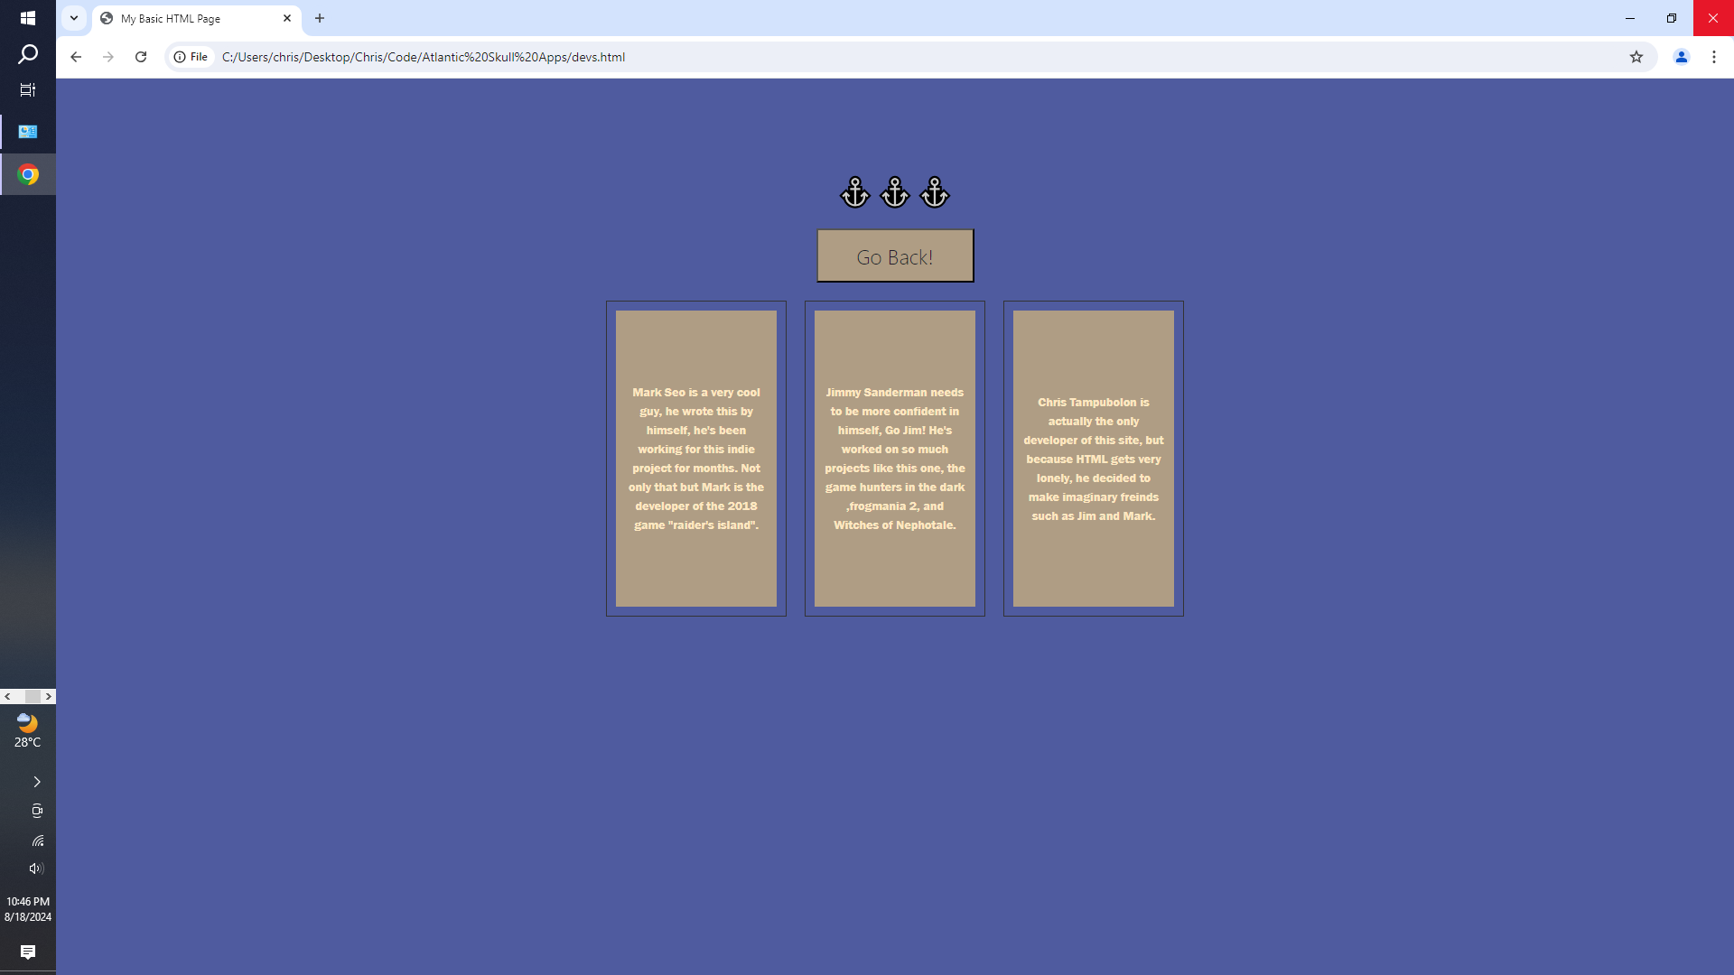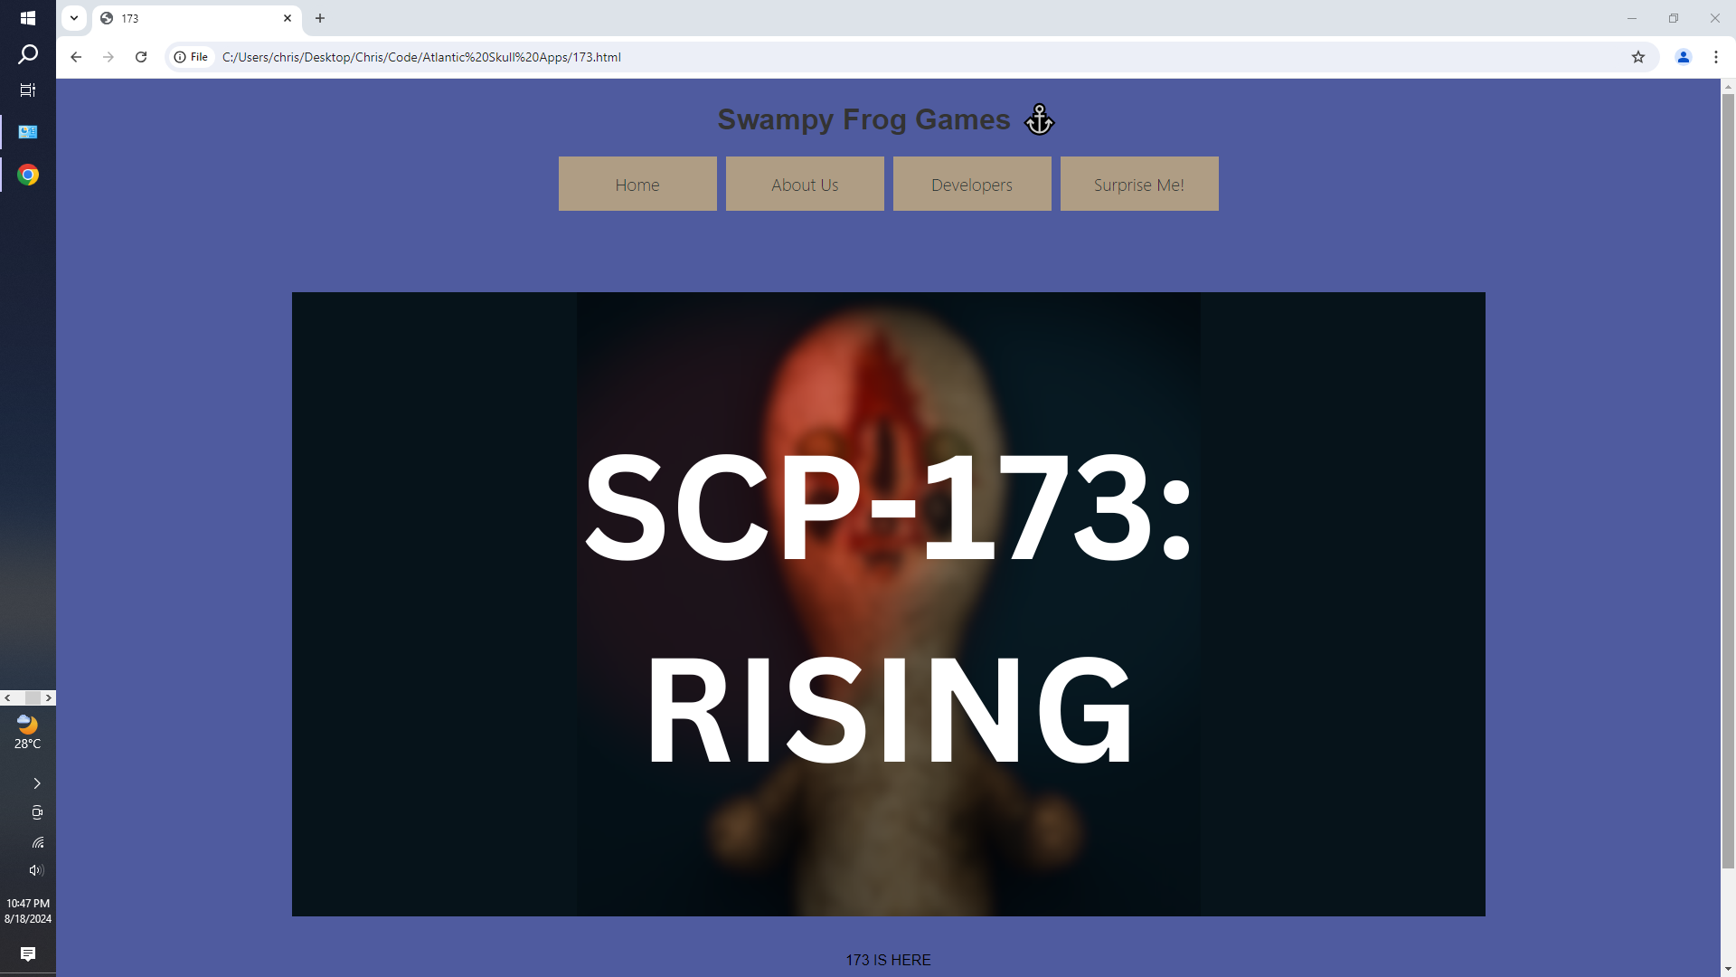

1. **GITHUB LINK**

[**https://github.com/OceanCloudsCool/swampyfrog**](https://github.com/OceanCloudsCool/swampyfrog)